**MySQL Install**

**By Tar**

**Solution**

**By Ivan**

1. 下载地址

<https://dev.mysql.com/downloads/mysql/>

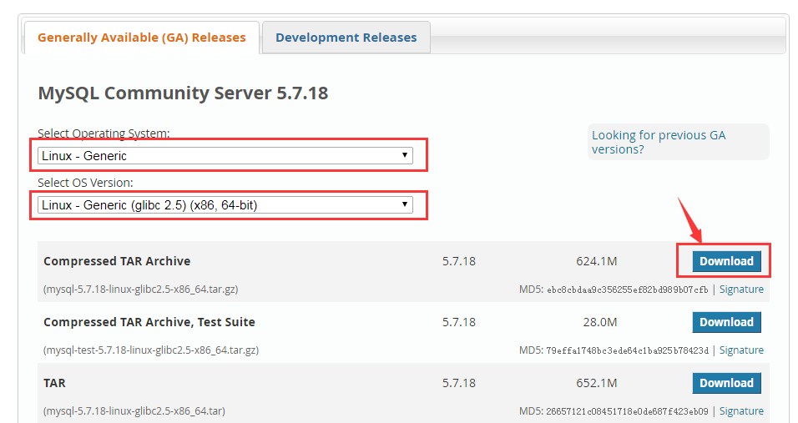

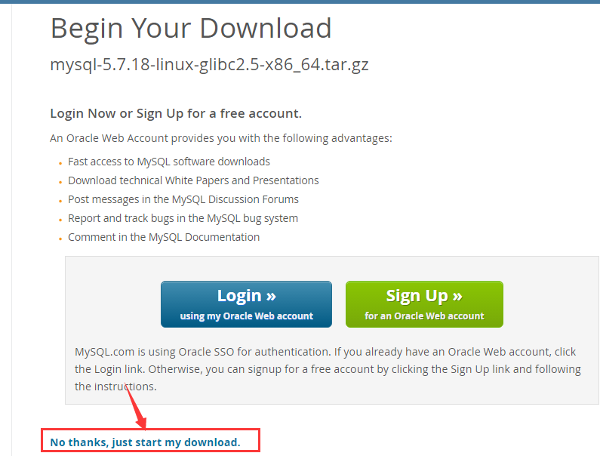

二．安装并配置

1.上传Mysql安装包mysql-5.7.18-linux-glibc2.5-x86_64.tar.gz到部署机

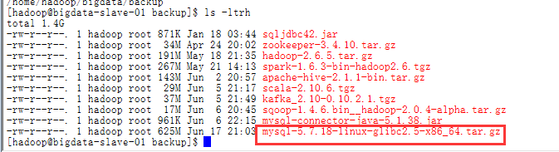

2.解压安装包

tar -zxvf mysql-5.7.18-linux-glibc2.5-x86_64.tar.gz



3.切换到root用户

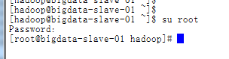

4.移动解压得到的目录到系统的本地软件目录/usr/local/

mv mysql-5.7.18-linux-glibc2.5-x86_64 /usr/local/mysql



5.进入安装Mysql软件的目录

cd /usr/local/mysql



6. 进入到mysql目录，可以发现，mysql5.7的版本和5.6的版本不同，没有/data目录，这里要自己创建一个data目录

data目录并不限定存放位置，但是为了方便，这里依旧直接放在mysql的根目录下

mkdir data

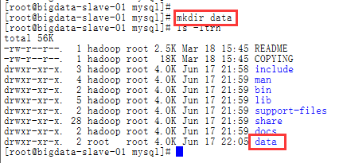

7. 建立mysql的用户和用户组

groupadd mysql #添加用户组

useradd -r -g mysql mysql

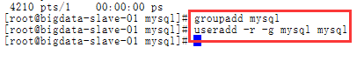

8. 改变mysql目录权限

chown -R mysql /usr/local/mysql/

chgrp -R mysql /usr/local/mysql/



9. 查看support-files文件夹的内容，发现并没有my_default.cnf默认的配置文件，如果没有默认的配置文件，需要手动创建一个my_default.cnf配置文件

touch my_default.cnf

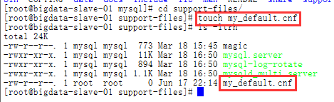

11.从网上找了一个配置文件，如下。当然这个配置文件可以根据需要自行修改

# For advice on how to change settings please see

# http://dev.mysql.com/doc/refman/5.7/en/server-configuration-defaults.html

# *** DO NOT EDIT THIS FILE. It's a template which will be copied to the

# *** default location during install, and will be replaced if you

# *** upgrade to a newer version of MySQL.

[mysqld]

sql_mode=NO_ENGINE_SUBSTITUTION,STRICT_TRANS_TABLES

#

basedir = /usr/local/mysql

datadir = /usr/local/mysql/data

port = 3306

socket = /var/run/mysqld/mysqld.sock

character-set-server=utf8

back_log = 300

max_connections = 3000

max_connect_errors = 50

table_open_cache = 4096

max_allowed_packet = 32M

#binlog_cache_size = 4M

max_heap_table_size = 128M

read_rnd_buffer_size = 16M

sort_buffer_size = 16M

join_buffer_size = 16M

thread_cache_size = 16

query_cache_size = 128M

query_cache_limit = 4M

ft_min_word_len = 8

thread_stack = 512K

transaction_isolation = REPEATABLE-READ

tmp_table_size = 128M

#log-bin=mysql-bin

long_query_time = 6

server_id=1

innodb_buffer_pool_size = 1G

innodb_thread_concurrency = 16

innodb_log_buffer_size = 16M

innodb_log_file_size = 512M

innodb_log_files_in_group = 3

innodb_max_dirty_pages_pct = 90

innodb_lock_wait_timeout = 120

innodb_file_per_table = on

[mysqldump]

quick

max_allowed_packet = 32M

[mysql]

no-auto-rehash

default-character-set=utf8

safe-updates

[myisamchk]

key_buffer = 16M

sort_buffer_size = 16M

read_buffer = 8M

write_buffer = 8M

[mysqlhotcopy]

interactive-timeout

[mysqld_safe]

open-files-limit = 8192

vi my_default.cnf

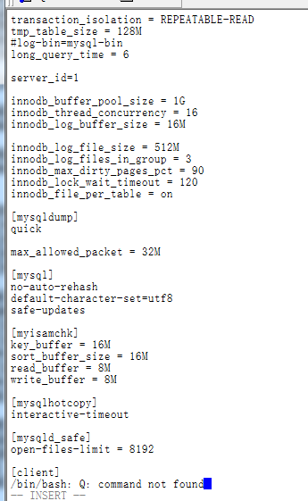

10. 初始化数据库：

bin/mysqld --initialize-insecure --user=mysql --basedir=/usr/local/mysql/ --datadir=/usr/local/mysql/data/ --datadir=/usr/local/mysql/data/

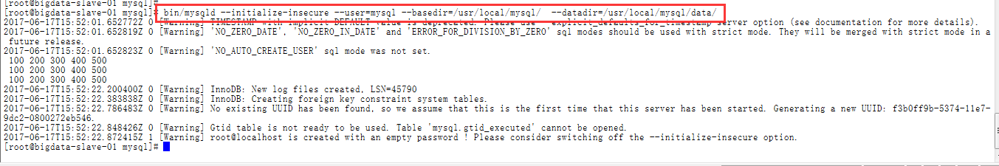

11. 复制上述的my_default.cnf和mysql.server配置文件到etc目录，之前复制过该文件到etc目录，它这里提示是否覆盖，输入Y覆盖

cp -a ./support-files/my_default.cnf /etc/my.cnf #会有一个选择是否覆盖原有文件，直接按 y回车选择是就可以



cp -a ./support-files/mysql.server /etc/init.d/mysqld



12. 启动MySQL服务

/etc/init.d/mysqld start

如果出现以下问题，

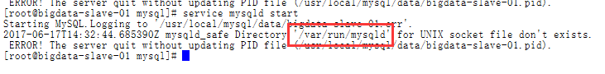

请采用以下方式修复

mkdir -p /var/run/mysqld

chown mysql:mysql /var/run/mysqld



再次启动

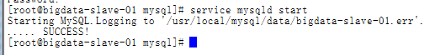

13.配置mysql环境变量

###################### mysql #########################

export MYSQL_HOME=/usr/local/mysql

export PATH=.:$MYSQL_HOME/bin:$PATH

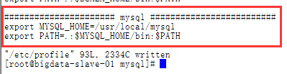

source /etc/profile



14.修改密码

mysqladmin -u root password '123456'

如果遇到以下问题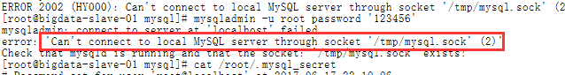

请参考下面解决

ln -s /var/run/mysqld/mysqld.sock /tmp/mysql.sock



再次修改密码



15.连接至MySQL

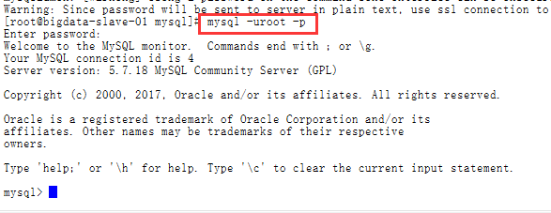

16.修改可远程访问

use mysql

update user set host = '%' where user = 'root';

如果出现以下问题



请参考以下方案解决

set sql_safe_updates=0;

set sql_safe_updates=off;

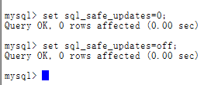

再次修改

